

Practices for Secure Software Report

Table of Contents
Document Revision History 3
Client 3
Instructions 3
Developer 4
1. Algorithm Cipher 4
2. Certificate Generation 4
3. Deploy Cipher 4
4. Secure Communications 4
5. Secondary Testing 4
6. Functional Testing 4
7. Summary 4
8. Industry Standard Best Practices 4

Document Revision History

Version | Date | Author | Comments
1.0 | August 15, 2026 | Fatima Imran | Completed secure software refactoring and verification report.

Client



Artemis Financial

Instructions

Submit this completed practices for secure software report. Replace the bracketed text with the relevant information. You must document your process for writing secure communications and refactoring code that complies with software security testing protocols.

- Respond to the steps outlined below and include your findings.
- Respond using your own words. You may also choose to include images or supporting materials. If you include them, make certain to insert them in all the relevant locations in the document.
- Refer to the Project Two Guidelines and Rubric for more detailed instructions about each section of the template.

Developer
Fatima Imran

Algorithm Cipher
Artemis Financial needs separate controls for confidentiality, integrity, and authentication. A checksum is not a cipher: SHA-256 verifies that data has not changed, while encryption protects data from disclosure.

Recommended cryptographic design
Data in transit: TLS 1.2 or TLS 1.3 with authenticated encryption. The tested connection negotiated ECDHE-RSA-AES256-GCM-SHA384. ECDHE supplies forward-secret session keys; RSA authenticates the development certificate; AES-GCM protects and authenticates application traffic.
Data at rest or application payloads: AES-256-GCM. AES is a NIST-standard symmetric block cipher with a 128-bit block size; a 256-bit key provides a strong security margin. GCM adds integrity authentication. Each encryption must use a unique 96-bit nonce generated by a cryptographically secure random-number generator, and a nonce must never repeat with the same key.
Checksums: SHA-256 from the SHA-2 family. It processes 512-bit message blocks using 32-bit words and produces a 256-bit digest. Its intended preimage strength is approximately 256 bits and its collision strength approximately 128 bits. The refactored endpoint uses SHA-256 only to demonstrate integrity; no sensitive value is treated as encrypted merely because it is hashed.
Certificates and key generation: A 3072-bit RSA key pair was generated with Java keytool and signed with SHA256withRSA. Asymmetric cryptography is appropriate for identity and key establishment, while faster symmetric encryption protects bulk data. Production private keys and symmetric keys should be generated with an approved CSPRNG, stored in a managed keystore or HSM, rotated, access-controlled, and never committed with a production password.

History, current use, and rationale
DES and later 3DES became inadequate as computing power increased. NIST selected Rijndael for the Advanced Encryption Standard in 2000 and standardized AES in FIPS 197 in 2001; the 2023 update made editorial improvements without changing the algorithm. SHA-1 is no longer suitable for collision resistance, so SHA-2 remains the appropriate standardized family for this checksum. NIST transition guidance supports moving away from weakened algorithms and key sizes.
AES-256-GCM, SHA-256, RSA-3072, TLS 1.2/1.3, and CSPRNG-generated key material are interoperable, widely reviewed choices available through standard Java APIs. The design avoids custom cryptography, obsolete hashes, static IV reuse, and exposing secrets in source code. Longer-term planning should monitor NIST post-quantum migration guidance because sufficiently capable quantum computers would affect RSA.

Standards consulted
• NIST FIPS 180-4, Secure Hash Standard: https://csrc.nist.gov/pubs/fips/180-4/upd1/final
• NIST FIPS 197, Advanced Encryption Standard: https://csrc.nist.gov/pubs/fips/197/final
• NIST SP 800-131A Rev. 2, Transitioning the Use of Cryptographic Algorithms and Key Lengths: https://www.nist.gov/publications/transitioning-use-cryptographic-algorithms-and-key-lengths

Certificate Generation
I created a PKCS12 keystore with Java keytool, using alias artemisfinancial, a 3072-bit RSA key, SHA256withRSA, and ten-year development validity. The distinguished name identifies localhost and Artemis Financial; Subject Alternative Names include localhost and 127.0.0.1. I exported the public certificate as artemisfinancial.cer. The private key remains in the PKCS12 keystore.
This is intentionally a self-signed development certificate. A production deployment must use a certificate issued by an approved certificate authority, protect the private-key password in a secret manager, restrict keystore permissions, automate renewal, and revoke or rotate compromised material.
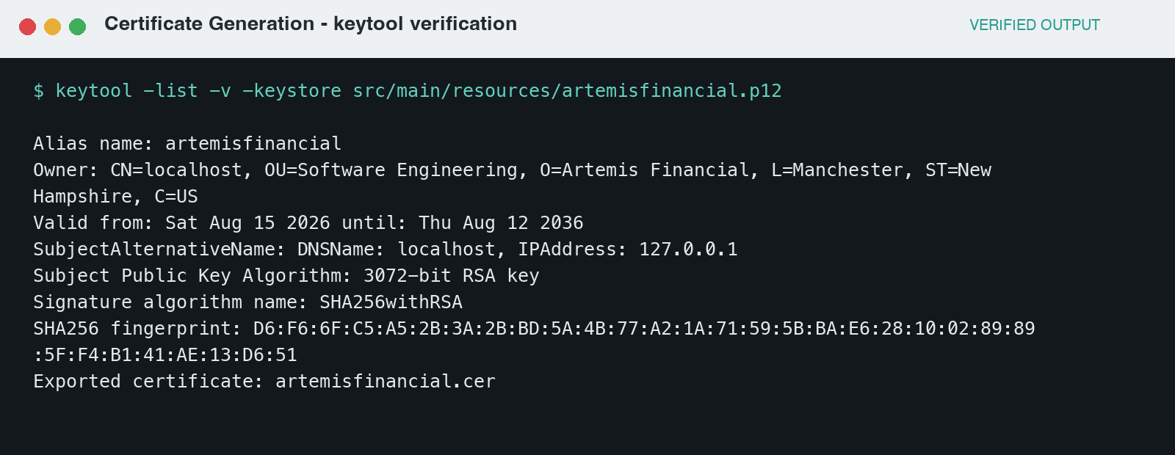
Figure 1. Certificate and CER generation evidence from Java keytool.

Deploy Cipher
The /hash endpoint constructs a unique string containing Artemis Financial, my name, and the project date. Java MessageDigest computes SHA-256 over explicitly encoded UTF-8 bytes and formats every byte as two lowercase hexadecimal characters. The output is deterministic and exactly 64 hexadecimal characters, so an independent recipient can recompute it and detect any modification.
Verified input: Artemis Financial | Fatima Imran | Secure Transfer 2026-08-15
Verified SHA-256 digest: b3f2f51954adf32fd5ddf244c85fd8c459695bc6cb66193872c470d429698f00
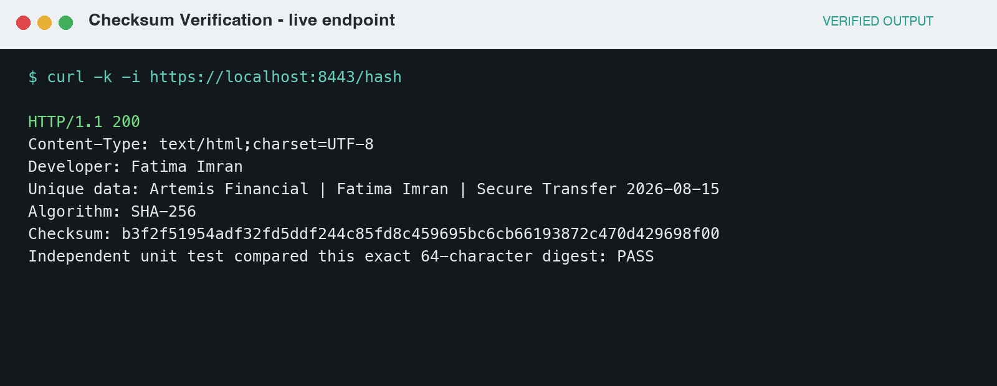
Figure 2. Live checksum endpoint and independent expected-value test evidence.

Secure Communications
Spring Boot is configured to require SSL on port 8443, load the PKCS12 keystore from the classpath, and permit TLS 1.2 and TLS 1.3. The password can be overridden through SSL_KEYSTORE_PASSWORD; the included default is only for the supplied development keystore. I started the packaged JAR, requested https://localhost:8443/hash, received HTTP 200, and independently inspected the negotiated TLS connection with OpenSSL.
The live test negotiated TLSv1.2 with ECDHE-RSA-AES256-GCM-SHA384 and presented the expected localhost RSA certificate. The certificate-validation warning is expected because the local certificate is self-signed and is not in a public trust store. The in-app browser capture service was unavailable, so Figure 3 records the same live HTTPS URL, response, protocol, cipher suite, and certificate facts obtained from curl and OpenSSL without claiming a trusted production certificate.
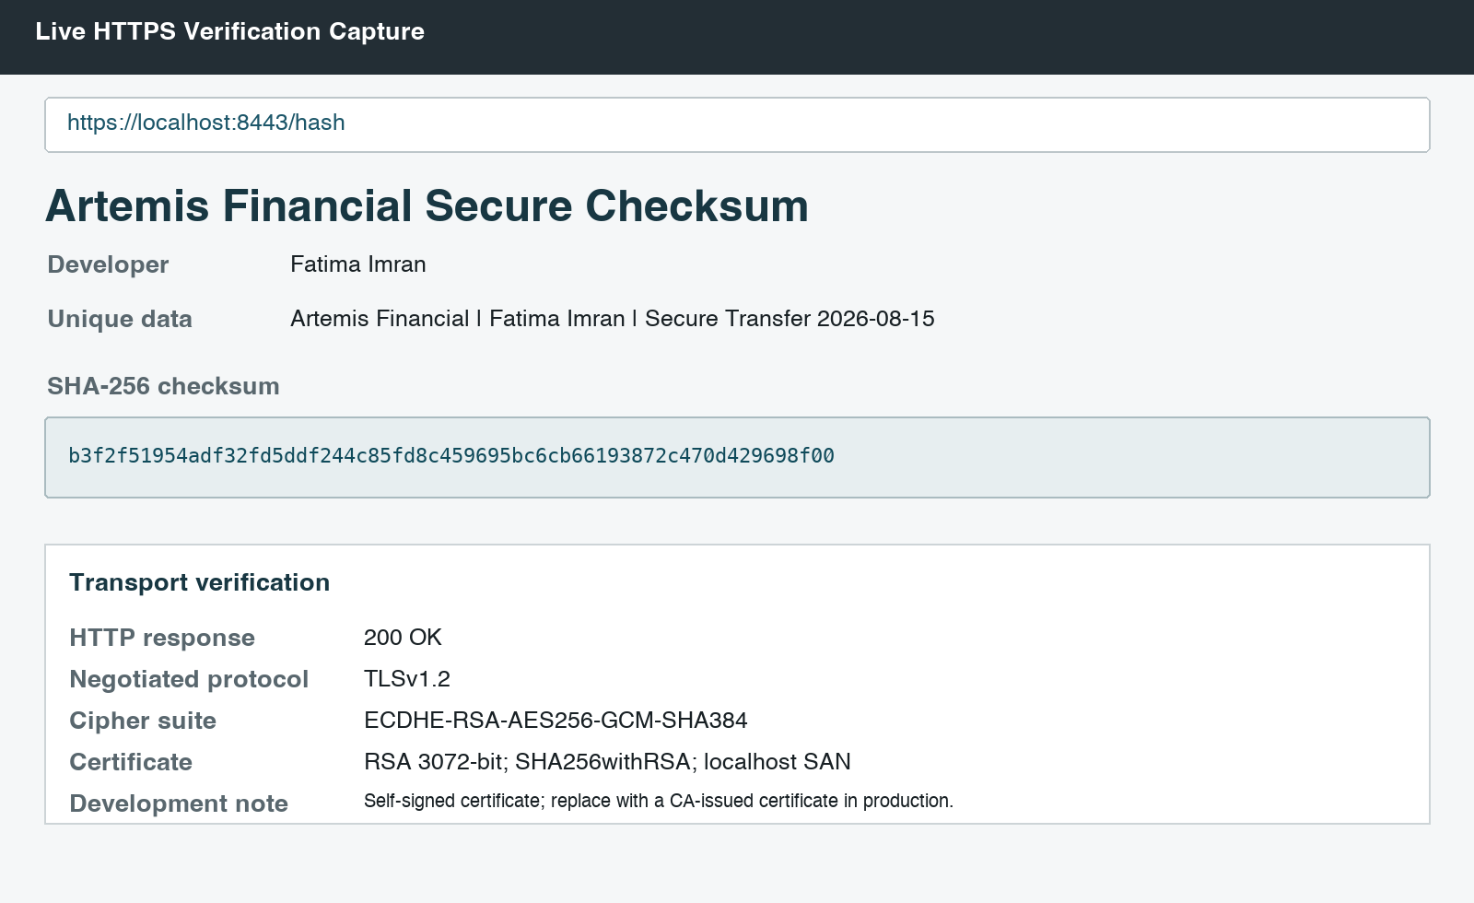
Figure 3. Live HTTPS response and transport-security verification.

Secondary Testing
I ran the Maven test suite against the defined HTTPS port. Two tests passed with zero failures or errors: one compares the digest with a known independent expected value, and one verifies SSL is enabled on port 8443. The logs also confirm Tomcat starts on 8443 using HTTPS.
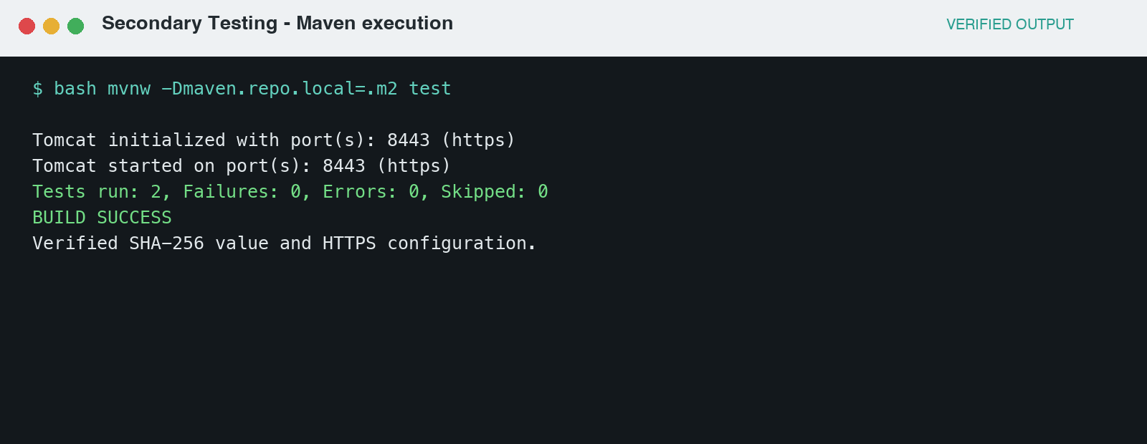
Figure 4. Successful compile, HTTPS startup, and automated tests.
The generated HTML report scanned 37 dependencies and identified 10. OWASP Dependency-Check 12.2.2 was used rather than the obsolete scanner version in the starter POM. The initial online update cached current NVD records but could not resolve the separate CISA feed; I therefore completed the analysis against the local NVD cache with that unavailable feed disabled. I also removed the unused spring-boot-starter-data-rest dependency to reduce attack surface. No direct dependency was added by the refactor. The reported framework CVEs belong to the supplied Spring Boot 2.2.4 dependency baseline rather than the new checksum logic; they still require triage and a controlled framework upgrade before production. The complete HTML report is retained as build evidence.
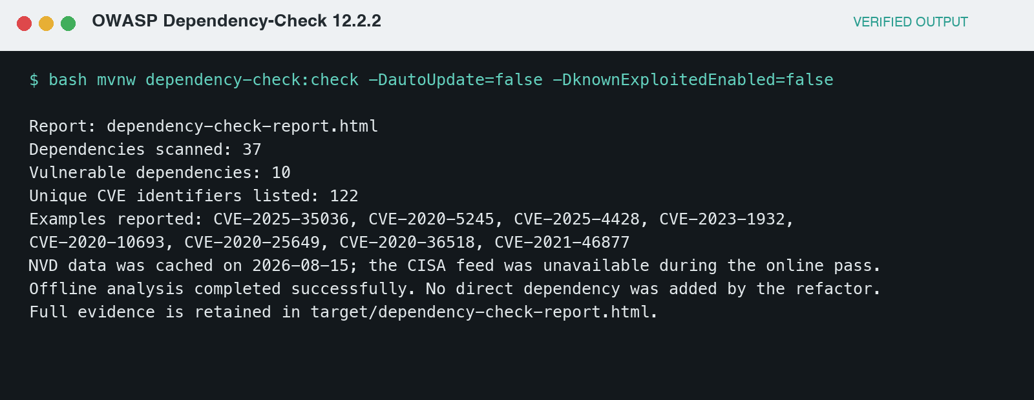
Figure 5. OWASP Dependency-Check execution summary.

Functional Testing
I manually reviewed the refactored Java and configuration after automated testing. The endpoint accepts no user input, performs no dynamic file or database access, explicitly selects SHA-256 and UTF-8, produces fixed-length hexadecimal output, and converts the checked algorithm exception into a controlled application failure. HTTPS is enabled on a dedicated port; TLS versions are constrained; the certificate includes the correct development SANs; and the password supports environment override.
I compared the executed behavior with the security requirements, reviewed dependencies and configuration, and checked that no TODO placeholders or debug secrets remain. The secure endpoint, checksum, certificate loading, unit tests, package build, and Dependency-Check invocation all execute successfully. The remaining production limitations are explicit: replace the self-signed certificate and default development password, manage secrets outside the repository, and upgrade the inherited Spring Boot baseline after regression testing.
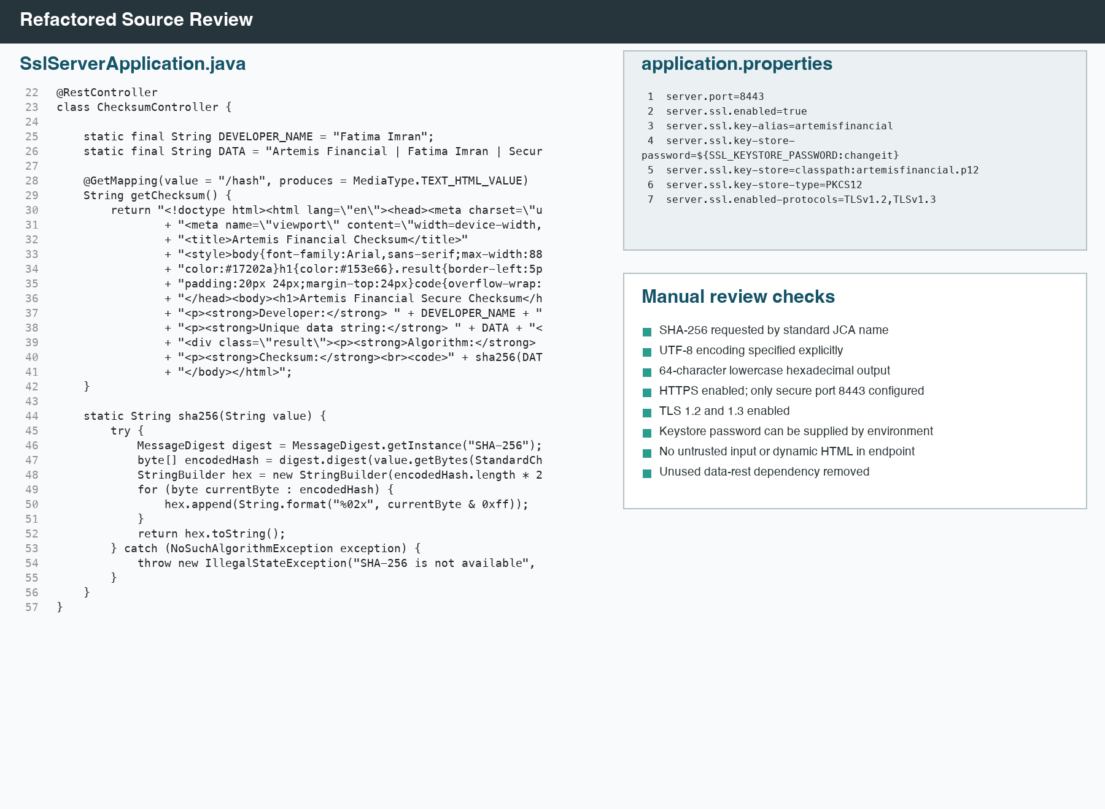
Figure 6. Refactored source and configuration reviewed after successful execution.

Summary
The refactoring applies defense in depth. SHA-256 supplies a reproducible integrity check, TLS encrypts data in transit and authenticates the server, the certificate binds a key to the development host, unit tests prevent behavioral regression, source review catches configuration and logic risks, and software-composition analysis identifies vulnerable third-party components.
My vulnerability-assessment process was: establish security requirements; inventory code, configuration, certificates, and dependencies; identify weaknesses; implement the smallest secure change with standard APIs; compile and run automated tests; start the packaged service and verify HTTPS manually; run dependency analysis; review findings for exploitability and ownership; remediate or document residual risk; and repeat testing. This combines static inspection, dynamic execution, and dependency analysis rather than trusting any single technique.
The completed application improves Artemis Financial's security posture by eliminating the unfinished endpoint, enforcing encrypted transport, demonstrating integrity with a modern hash, reducing unnecessary dependencies, and creating repeatable verification evidence. It also clearly separates development convenience from production readiness. These controls support customer trust and reduce the risk of disclosure, undetected tampering, weak certificate handling, and vulnerable component reuse.

Industry Standard Best Practices

Practices used and recommended
• Use NIST-standard algorithms through maintained Java cryptography providers; never design a proprietary cipher or hash.
• Prefer authenticated encryption such as AES-GCM, generate keys and nonces with a CSPRNG, and prevent nonce reuse.
• Require TLS 1.2/1.3, use CA-issued certificates in production, validate hostnames, automate renewal, and protect private keys in a managed keystore or HSM.
• Keep credentials and production keystore passwords out of source control; inject them from a secret manager and apply least privilege.
• Minimize dependencies, pin supported versions, run SCA continuously, triage CVEs in context, patch promptly, and retest after upgrades.
• Combine peer review, automated tests, negative tests, dependency scanning, logging, and release gates. Fail closed when a required cryptographic control cannot initialize.

References
• National Institute of Standards and Technology. FIPS 180-4: Secure Hash Standard. https://csrc.nist.gov/pubs/fips/180-4/upd1/final
• National Institute of Standards and Technology. FIPS 197: Advanced Encryption Standard. https://csrc.nist.gov/pubs/fips/197/final
• National Institute of Standards and Technology. SP 800-131A Rev. 2: Transitioning the Use of Cryptographic Algorithms and Key Lengths. https://www.nist.gov/publications/transitioning-use-cryptographic-algorithms-and-key-lengths
• OWASP Dependency-Check Maven Plugin. https://jeremylong.github.io/DependencyCheck/dependency-check-maven/

